As energy consumption has grown over the years, the impacts to the environment has grown significantly as well. Through this analysis, we wanted to get a better understanding of the relationship between energy consumption and the carbon dioxide emissions for various sectors and states as reported by the EIA.

The EIA provides 4 different sectors for energy consumption and emissions – Industrial, Transportation, Residential and Commercial.

* Industrial represents facilities and equipment used for manufacturing, agriculture, mining and construction.
* Transportation includes vehicles to transport people or goods such as cars, trucks, buses, motorcycles, trains, aircraft, boats, barges, and ships.
* Residential includes homes and apartments.
* Commercial sector includes offices, malls, stores, schools, hospitals, hotels, warehouses, restaurants and places of worship and public assembly.

There is a fifth sector for electric power which we did not include in the analysis as this electric sector consumes primary energy to generate most of the electricity the other four sectors consume.

<https://www.eia.gov/energyexplained/index.php?page=us_energy_use>

We focused on the past 10 years of available data, as technology has grown very rapidly especially during this time. The energy consumption and emissions by sector data are available through 2018, whereas the emissions by state data is only available through 2016.

From looking at the definitions for these sectors, we wanted to see if the industrial and transportation sectors would result in the highest energy consumption and emissions, as activities such as manufacturing require large amounts of energy to run, which we thought would also result in high emissions.

The Gulf Coast has the majority of large refineries in the United States, with Texas alone accounting for about 30% of the refining capacity in the United States. With globalization, many of the ports in the East Coast, Florida, Gulf Coast and West Coast have many import and export activities, where products then travel by rail and trucks to the port or inland. Crude is imported from Canada and transported by rail to the refineries.

We narrowed into the data to specifically answer these 4 questions.

* Which are the fastest growing sectors for energy consumption?
* Which sectors produce the most emissions, and within each sector, which product group produces the most emissions?
* Which state produced the most emissions?
* As energy consumption increases, does CO2 emissions increase?

1. **Which are the fastest growing sectors for energy consumption?**

Our results show that the industrial sector consumes the highest energy consumption, followed by transportation, residential and commercial.

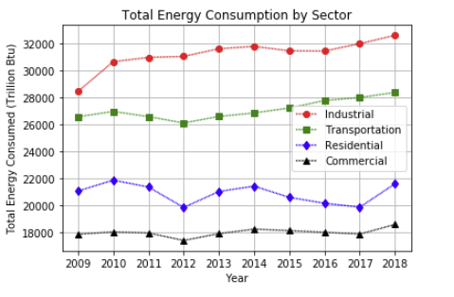

We found that the industrial sector also has the fastest growth over the past 10 years, followed by transportation, commercial and residential. One interesting difference is that even though commercial energy consumption is less than residential energy consumption, the commercial sector is growing at a faster rate than the residential sector. The first graph shows that the energy consumption is higher on residential, but once you apply the growth rate, commercial is actually growing at a faster pace.

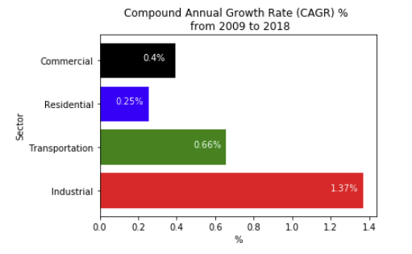

The box plot grouped by sector shows that the commercial and residential data is for the most part evenly distributed. The industrial and transportation sectors are skewed up, where the longer part of the box is above the medium. There is just one outlier for the industrial sector. This means that the lower energy consumptions figures in BTUs are closer together than the larger energy consumption figures.

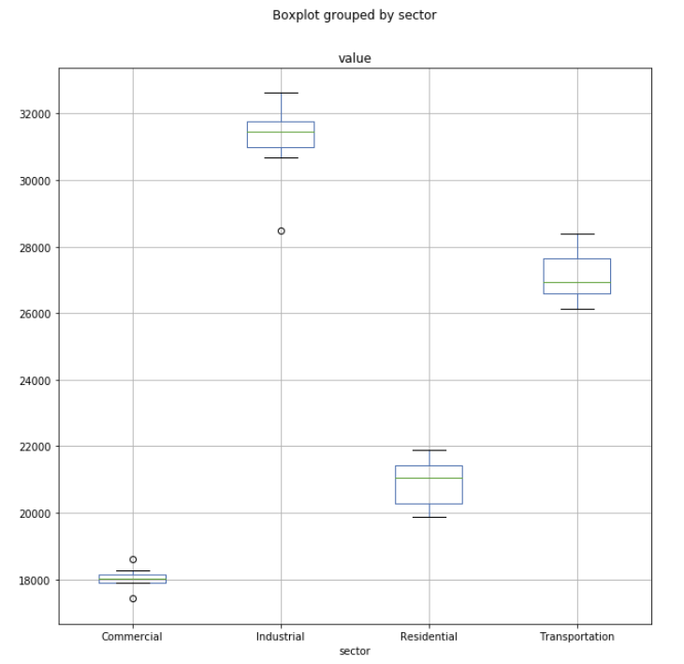

1. **Which sectors produce the most emissions, and within each sector, which product group produces the most emissions?**

Our data shows that the transportation sector produced the most emissions, followed by industrial, residential and commercial. Emissions from transportation is the highest by a large amount at above 35,000 million metric tons, whereas the other 3 sectors are under 15,000 million metric tons.

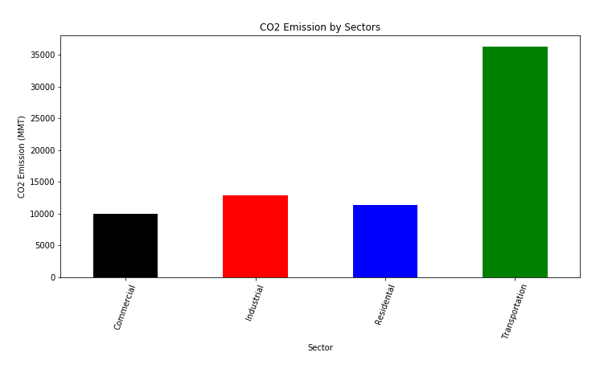

The emissions for the transportation sector has increased steadily since 2012. For the industrial sector, the increase has been steady since 2016. As opposed to these 2 sectors, the commercial and residential sectors have declined since 2014, but showed it turned in 2017, where emissions have increased between 2017 and 2018.

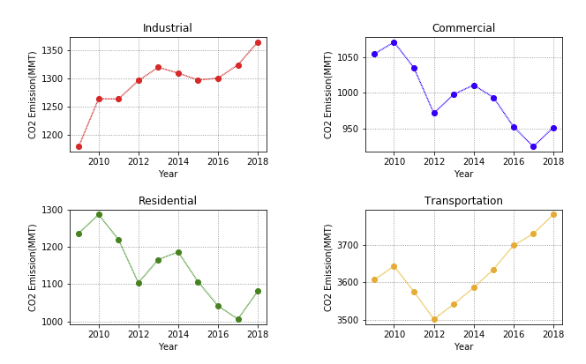

Our data showed that the largest share of the CO2 emissions came from emissions from petroleum, followed by natural gas. In the petroleum category, the majority of the emissions came from gasoline, diesel and jet fuel. Per EIA, the carbon intensities for the petroleum products are higher than natural gas.

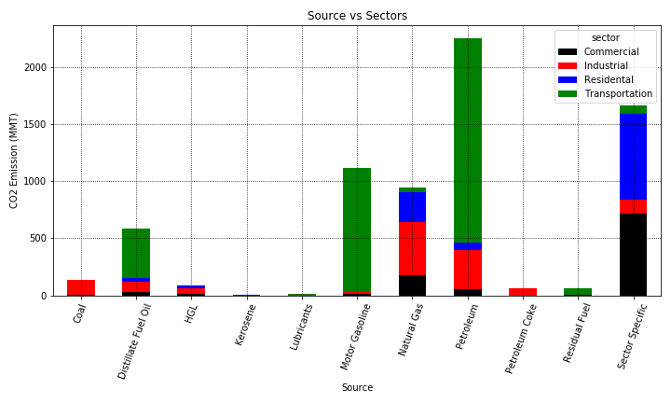

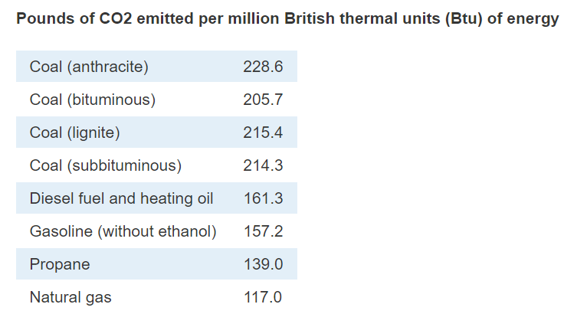

<https://www.eia.gov/tools/faqs/faq.php?id=73&t=11>

1. **Which states produced the most emissions?**

Texas, followed by California, has the highest amount of emissions in the United States. Both of them have the highest emissions in the transportation sector.

This may explain why California has implemented the Low Carbon Fuel Standards (LCFS) a few years ago, to incentivize producers and blenders to use lower carbon intensity fuels. The producers and blenders can receive LCFS credits when the fuel they use has a lower carbon intensity than the standard carbon intensity. The cost is passed on to the Californian consumer, who pays about 15 cents per gallon extra at the pump.

Texas, Louisiana and California have a high amount of emissions in the industrial sector as well. This is not surprising as most of the large scale refineries can be found in these Gulf Coast as well as California.

Per the EIA’s State Energy Profile Overview for Texas, our state is the largest energy-producing state and the largest energy-consuming state in the nation. The industrial sector, including its refineries and petrochemical plants, accounts for half of the energy consumed in the state. EIA’s State Overviews for Louisiana and California also confirm that these states along with Texas are the 3 largest in oil refining capacity.

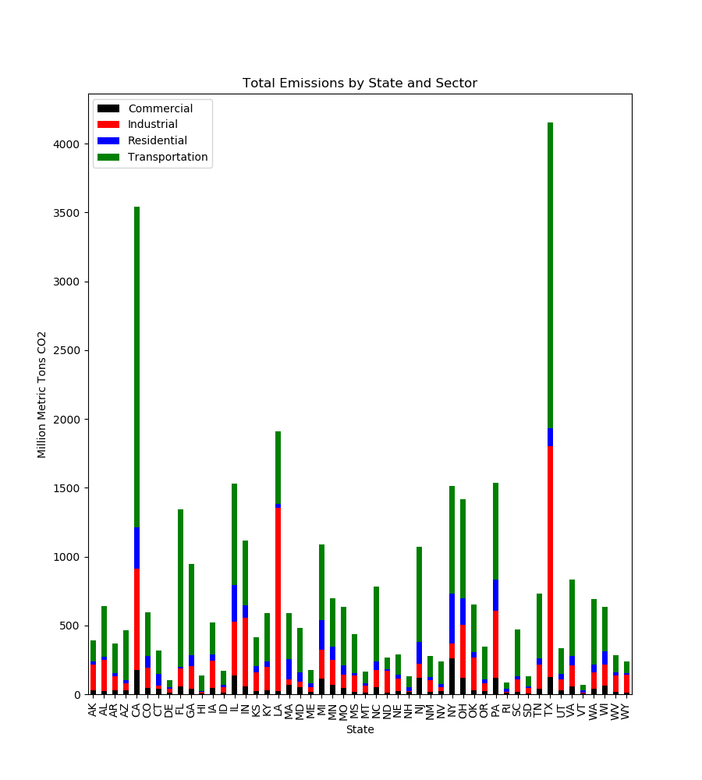

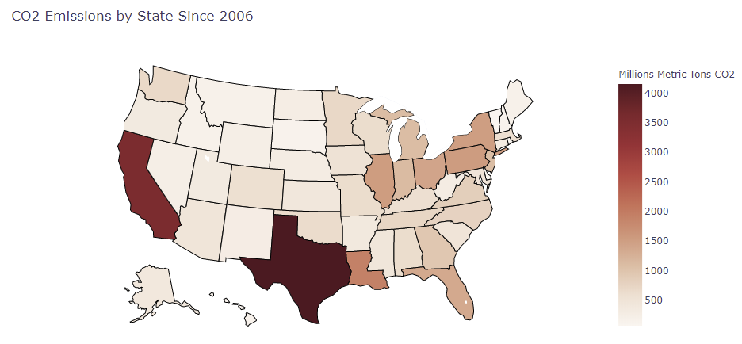

1. **As energy consumption increases, does CO2 emissions increase?**

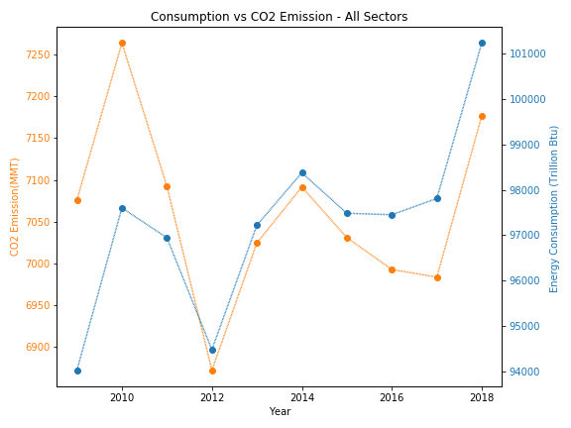

Based on the chart above, CO2 emissions closely follow energy consumption.

Emissions fell during the recession in 2009 but rose sharply in 2010. The use of coal accounted for a significant part of the growth of emissions in 2010.

There was a large decrease in CO2 emissions from 2010 to 2012 due to

1. Better fuel efficiency of vehicles
2. Less coal used to generate power, as electric utilities have started using natural gas which has a lower carbon intensity than both coal and petroleum products
3. There was a mild winter in 2012 which meant that Americans did not need to use as much heat for their homes.

The EIA reported that starting in 2015, natural gas has become more prevalent and used as a replacement for coal, which accounts for the decrease in CO2 emissions the past few years.